State of California — Department of State Hospitals GAVIN NEWSOM, Governor


Department of State Hospitals - NAPA
2100 Napa-Vallejo Highway
Napa, California 94558
Phone: (707) 253-5728 Fax: (707) 253-5299

The Presiding Judge

RE:
Subject: Non-restorable patient at DSH-Napa from [COMMITTING COUNTY SUPERIOR COURT] County
SC:
NA:

Your Honor:

The enclosed report on the above-named patient is submitted as required under Penal Code sections 1370, subdivision (b)(1)(A) referring them back to court as unlikely to be restored to competence.

Penal Code section 1370, subdivision (b)(1)(A) states, “If the report indicates that there is no substantial likelihood that the defendant will regain mental competence in the foreseeable future, the committing court shall order the defendant to be returned to the court for proceedings pursuant to paragraph (2) of subdivision (c) no later than 10 days following receipt of the report. The court shall transmit a copy of its order to the community program director or a designee.”

We request the court issue a transportation order to return the above named patient to the committing court within 10 days of receipt of this report and begin conservatorship proceedings if appropriate. Once the court issues a transportation order, we request that they be returned to court forthwith. Please call DSH-Napa to coordinate transport.

Sincerely,
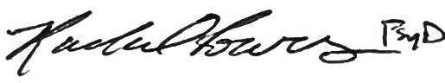
Rachel Powers, Psy.D. for
Seth Judd, D.O., or Designee
Medical Director

Enclosure

CC Defense Counsel, District Attorney, Public Guardian (If conservatorship investigation is recommended)

